1. Which is the correct formula to find I from the formula P =I2R?

1. Calculate the cosine of the following angle (a) in the figure below.

5

a

4

6.4

1. The SI unit for Impedance is?

1. The electrical quantities symbol for Inductive Reactance is?
2. Kelvin is the measurement of?
3. Which instrument would be used to measure Power?
4. The SI unit for Energy is the?
5. A 25 kilogram bag of cement falls to the ground from a height of 5 meters.   
   How much force will the bag hit the ground with?
6. A wheel barrow is an example of what class of lever:
7. Calculate the effort required to lift a 10 Newton load with   
    a crowbar in the figure below.  
   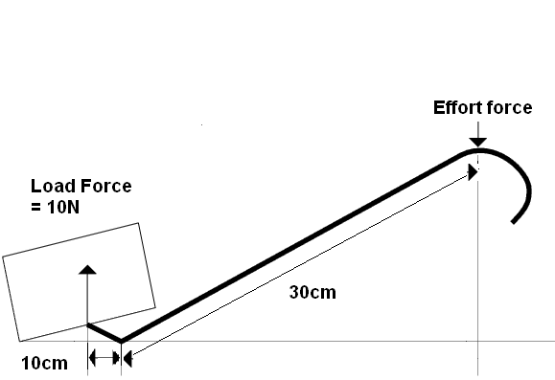
8. One set of gears are connected together. The smaller cog has 12 teeth   
   and the larger cog has 20 teeth. The smaller cog rotates 40 times  
   per second. How many times per second will the larger cog rotate?

1. Two pulleys are used to lift a load of 19000 Newton’s, 4 metres   
   above a surface. How much effort would be required to lift the load?

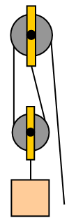

1. An electric motor has an input of 4kW and an output of 3.3KW.   
   The efficiency of the motor is?
2. What is the correct formula for calculating work done?
3. Identify four types of material which could act as a good insulator.
4. A 6mm2 cooper conductor has a resistivity of 1.78x10-8 and is   
   87 meters long. What is the resistance of the conductor?

1. Which of the following statements is correct?
   1. As the voltage and the current increases, the resistance will decrease.
   2. As voltage increases, the current will also increase if the resistance stays the same.
   3. Current will decrease if resistance decreases and voltage stays the same.
   4. Voltage will increase if resistance increases and the current increases.
2. What formula would be used to calculate Power from Voltage and Resistance?

1. Three resistors of equal value are placed in series and are connected   
   to a 12 Volt supply, 1.3 Amps flows through the resistors. What are   
   the values of each of the resistors?
2. Four resistors with values of 12 Ohms, 7.5 Ohms, 9 Ohms and 4.8 Ohms   
   are wired in parallel and connected to a 110 Volt supply. How much   
   current will flow through the 7.5 Ohm resistor?

1. What is the total resistance of the following resistors when wired in parallel:   
   13 Ohms, 25 Ohms, 6 Ohms, 18 Ohms and 9 Ohms?

9Ω

18Ω

6Ω

25Ω

13 Ω

1. A circuit has a total resistance of 12 Ohms and 6.44 Amps flows through it.   
   How much power will the circuit dissipate?
2. An electric heater with a resistance of 16 Ohms is connected to a   
   220 Volt d.c. supply. What is the power dissipated by the heater?

1. Calculate the volt drop of a circuit with a resistance of 1.2 Ohms with a   
   current flow of 15 Amps.

1. The effect that allows us to perform electroplating is:

1. The Tesla is the measurement for:

1. Two current carry conductors are placed side by side (see fig below).   
   draw direction of magnetic field?

1. A current carrying conductor is placed within a magnetic field. Indicate the   
    direction will the conductor (in the fig below) move?

N

S

1. An alternator has a frequency of 60Hz. How long does it take to perform   
   two full revolutions?
2. What is the generated emf when a 5000mm long conductor cuts a (L5.4)  
   magnetic field of 0.5 Teslas at a velocity of 0.42 m/s?

1. Which electronic device is designed to store an electrical charge? (L6.2)

1. 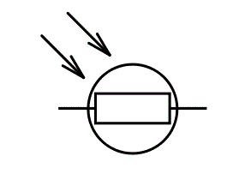Which electronic device has the symbol (in the fig below)? (L6.2)

1. What names are given to the two connections of a diode? (L6.2)